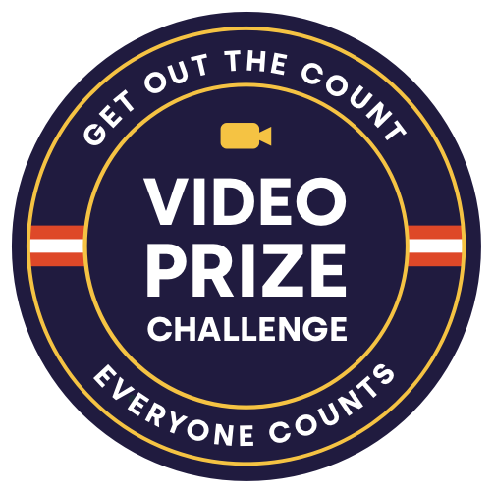

Get Out the Count Video Prize Challenge

OVERVIEW
Census Accelerate, an initiative within the Census Open Innovation Labs at U.S. Census Bureau, has launched its first-ever Video Prize Challenge to reward the most engaging, impactful and informative videos about the 2020 Census - with a total of $50,000 in cash prizes. Census Accelerate has partnered with national and local advocacy groups, the entertainment industry, federal agencies, civic engagement groups and more to leverage outreach efforts of cross-sector organizations dedicated to ensuring a complete and accurate count. Now, we’re challenging civically engaged content creators, ranging from students to pros, in supporting a complete count of everyone living in the United States.

2020 Census Video Prize Info Session- Monday, March 30th at 4pm EDT.

IMPORTANT LINKS
- Challenge.gov | Extended deadline - April 17th at 11:59pm EST
- FAQ’s available at accelerate.census.gov/video-challenge/
- Prize Challenge Info Session | March 30th - 4pm EST
- Questions? Contact: census.accelerate@census.gov

SAMPLE OUTREACH EMAIL:

Community. It’s a complex word that can describe a feeling, a place or a person. At the U.S. Census Bureau, the term “community” is at the center of our mission. As families and individuals across America settle into a new reality, people are searching for ways to connect with their community from their living rooms. Parents and caregivers are looking for something to teach or do with their children, businesses are trying to stay afloat, and local governments are trying to keep their communities safe and informed.

While many people are increasingly worried about the current situation, it’s important to remember that future funding for many of the critical healthcare and emergency services being used today will be determined by communities participating in the 2020 Census.

That is why the U.S Census Bureau’s innovation team — the Census Open Innovation Labs (COIL) — has launched a first-of-its-kind Video Prize Challenge to engage communities and individuals to help get the word out about the 2020 Census and encourage people to self-respond to the Census through the phone, mail or online. COIL will award a total of $50,000 in cash prizes to creators of the most impactful, inspiring, creative, and culturally relevant videos ranging from 30 seconds to three minutes. And the best news - you can do this from your own living room!

The goal of the competition is to encourage folks to self-respond to the 2020 Census, especially hard-to-count communities, through fun, engaging and informative short-form videos. This open call for content is designed to help educate and motivate individuals so that they understand why it’s critical to complete the 2020 Census — from getting the funding their community needs for hospitals and healthcare infrastructure planning, community services, as well as funding for schools, roads, emergency response, and more. In addition, the population counts from the 2020 Census impacts representation in congress, and in local levels of government.
The competition is for everyone! Families, students, kids and professionals are all welcome to submit a video! To learn more about

Please join a Prize Challenge Info Session on Monday, March 30th at 4:00pm ET.

Submission period is open through April 17th at 11:59pm EST; winners will be announced in May. Three prizes awarded include a $30,000 grand prize, $10,000 runner up, and a $10,000 student prize.

For more information see our FAQs here, visit challenge.gov or contact the team at census.accelerate@census.gov.

Thanks,

SAMPLE SOCIAL MEDIA POSTS:

Got some time on your hands? Check out how making a short video for the census could win you $30,000. (link)…and if you haven’t responded yet, go to 2020census.gov today! #GetOutTheCount #2020Census #CreativesForTheCount

Calling all content creators! Check out how making a short video for the census could win you up $30,000. (link)…and if you haven’t responded yet, go to 2020census.gov today! #GetOutTheCount #2020Census #CreativesForTheCount

Calling all students! Check out how an original short video for the census could win you up $30,000. (link)…and if you haven’t responded yet, go to 2020census.gov today! #GetOutTheCount #2020Census #CreativesForTheCount

Create a short video by April 17th to help promote the census and you could win up to $30,000. (link)…and if you haven’t responded yet, go to 2020census.gov today! #GetOutTheCount #2020Census #CreativesForTheCount

For the first time, the Census Bureau will award a total of $50,000 in cash prizes to creators of the most impactful, inspiring, creative, and culturally relevant original videos ranging from 30 seconds to 3 minutes. (link) And the best news: you can do this from your own living room! (After filling out your #2020Census online of course, at 2020census.gov) #GetOutTheCount #2020Census #CreativesForTheCount

Link:

https://bit.ly/GOTCVideoChallenge

Hashtags:
#2020Census
#CreativesForTheCount
#GetOutTheCount
#GetCounted
#WashYourHandsThenGetCounted

